Security material vnpa jkqa luik wdsl
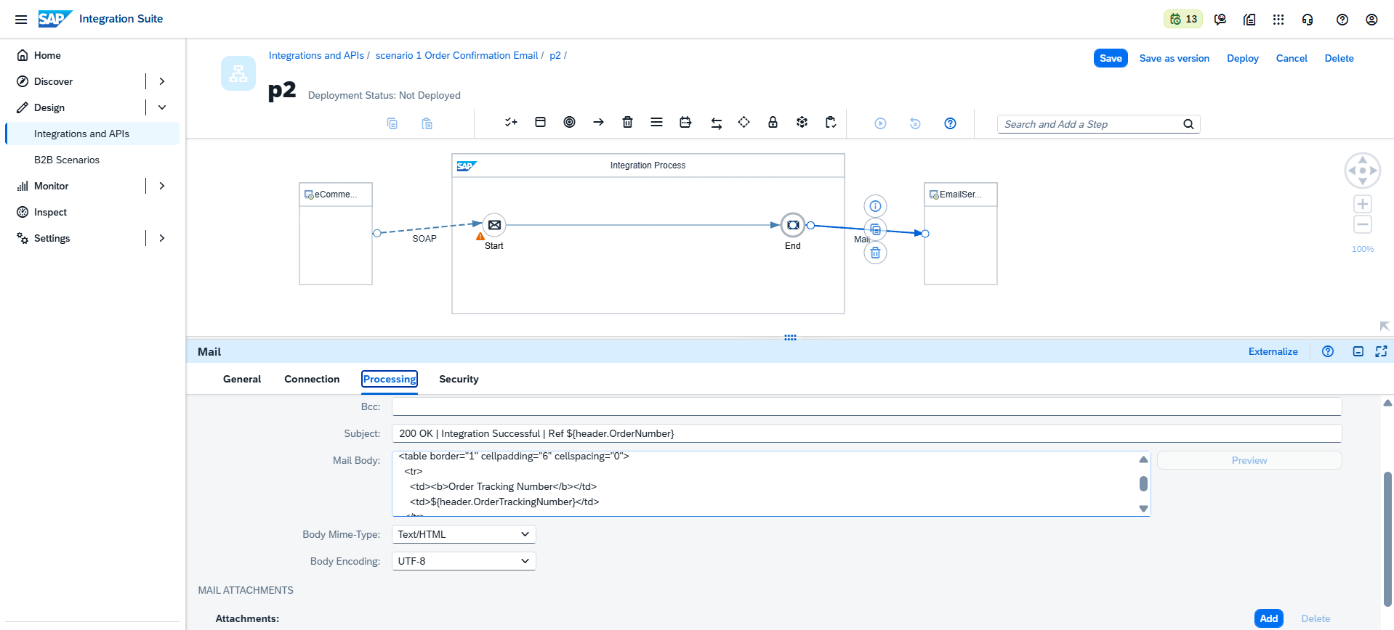
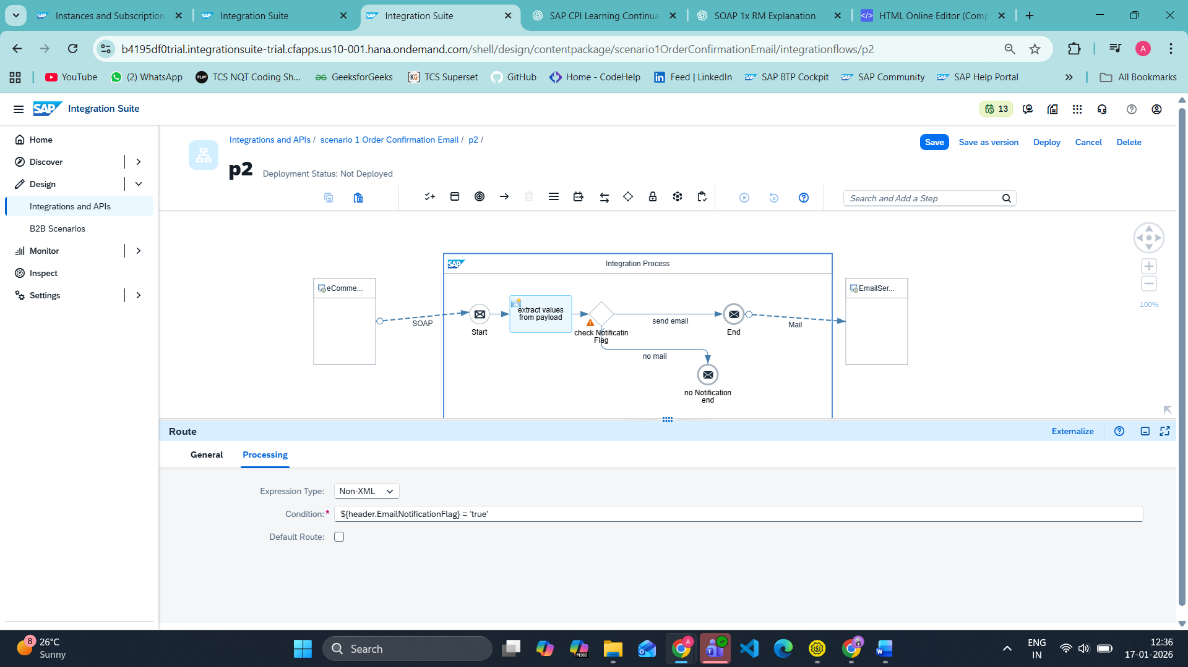
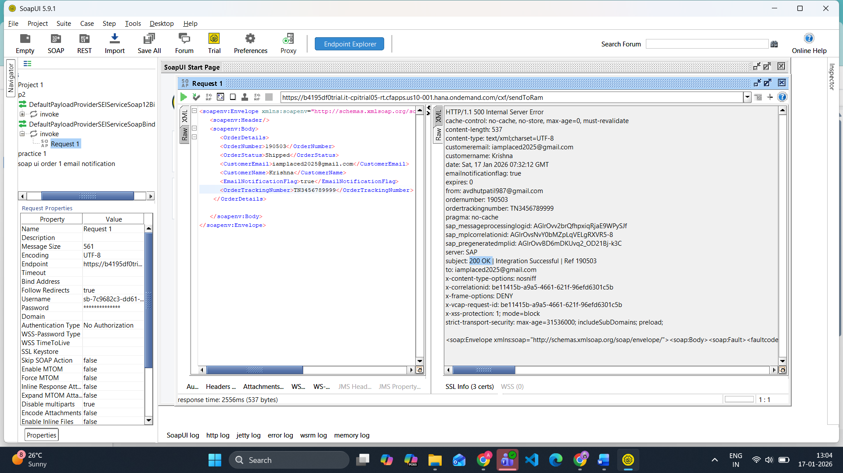
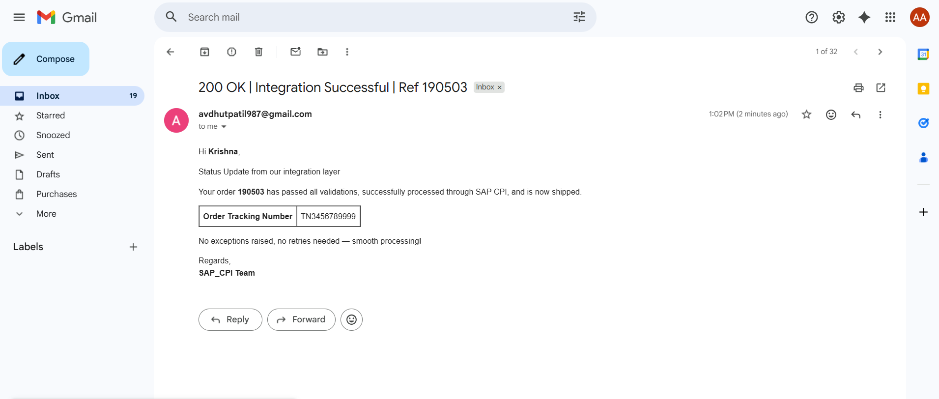
Type 1
<p>Hi <b>${header.CustomerName}</b>,</p>

<p>Status Update from our integration layer </p>

<p>Your order <b>${header.OrderNumber}</b> has passed all validations,
successfully processed through SAP CPI,
and is now shipped.</p>

<table border="1" cellpadding="6" cellspacing="0">
<tr>
<td><b>Order Tracking Number</b></td>
<td>${header.OrderTrackingNumber}</td>
</tr>
</table>

<p>No exceptions raised, no retries needed — smooth processing!</p>

<p>Regards,<br/>
<b>SAP_CPI Team</b></p>
subject
200 OK | Integration Successful | Ref ${header.OrderNumber}

Type 2
<p>Dear <b>${header.CustomerName}</b>,</p>

<p>Good news! <br/>
Your system access request <b> ${header. OrderNumber } </b>has been approved and successfully provisioned.</p>

<table border="1" cellpadding="6" cellspacing="0">
<tr>
<td><b>User ID</b></td>
<td>${header. OrderTrackingNumber }</td>
</tr>
</table>
<p>You may now log in and start exploring — responsibly, of course .</p>
<p>If you face any issues, our support team is just a ticket away.</p>
<p>Regards,<br/>
<b>SAP_CPI Team</b></p>
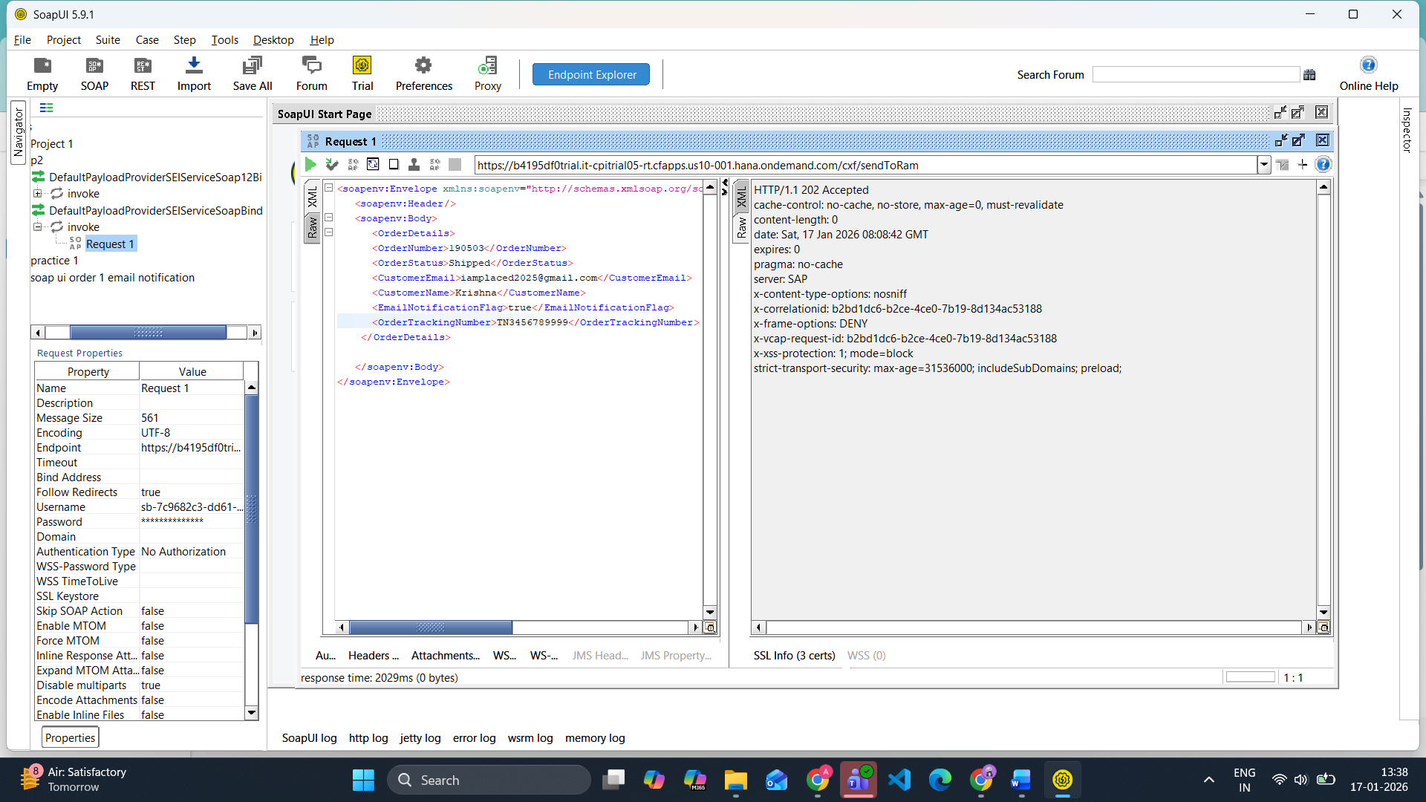

Issue resolved
<td>${header. OrderTrackingNumber }</td> this extra gap between order lead not fetch values
<td>${header.OrderTrackingNumber }</td> correct

